Eating in prison

Workbook 1

Reading canteen sheets and menus

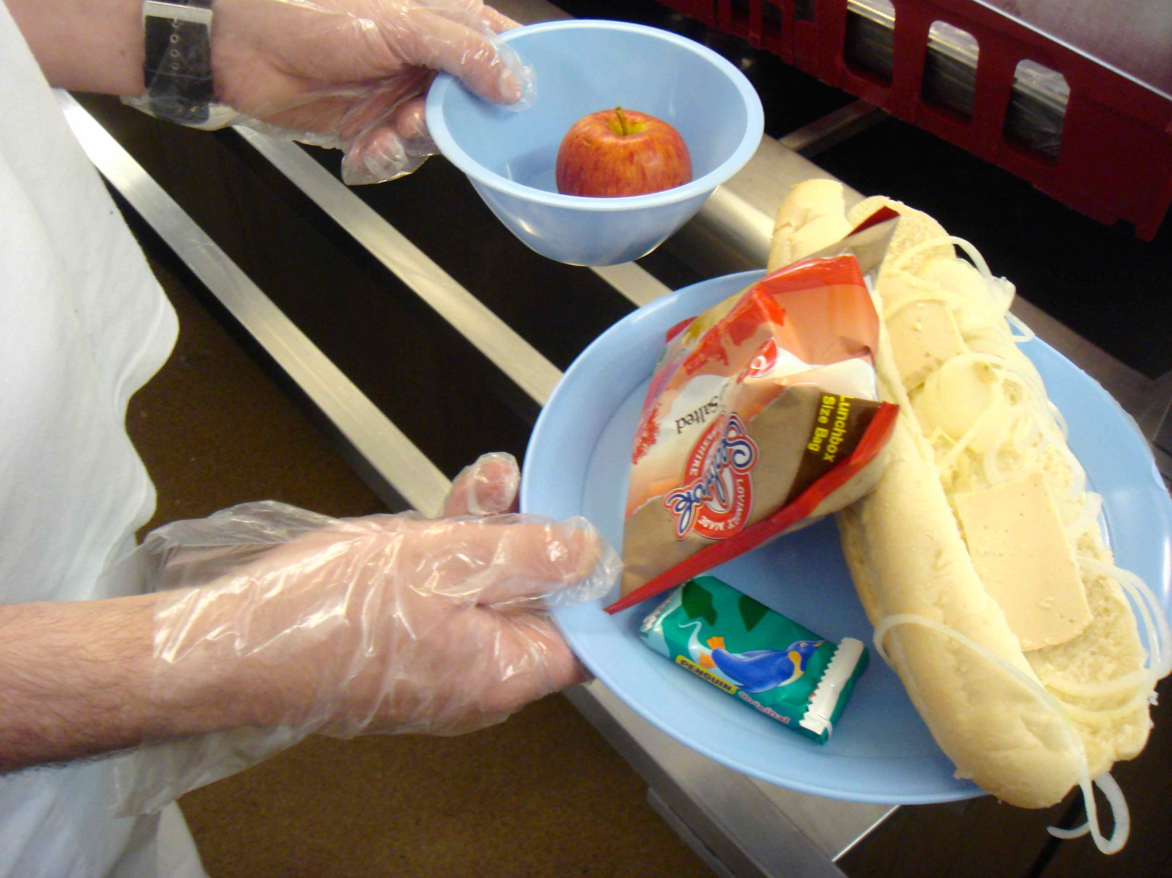

Contents page

How to use the workbook 3

Unit 1 The canteen sheet 5
Important words you need to know

Unit 2 The canteen sheet – ordering items 1 11

Unit 3 The canteen sheet – ordering items 2 17

Unit 4 Reading a prison menu 21

Unit 5 What food is good/bad for me? 27

Test yourself 31

End of workbook check 34

Answers 35

How to use the workbook

This workbook has activities on
- reading
- writing
- grammar
- vocabulary
You need a pen or pencil.

Do the activities then check your answers using the Answers pages at the back of the workbook.

Sometimes there will be a Glossary for new words. A glossary is a very short dictionary that explains the meanings of new words.

There is sometimes some information to read:

Information
If you see a box like this, read the information carefully. It will help you with the next task.

Sometimes you have to do some work outside your cell:

If you see something in a box like this, it means you have to do something outside your cell. For example, maybe you will have to;
- ask someone a question
- check something with your landing officer
- read something
- find or get something

Eating in Prison Workbook 1 – Reading a canteen sheet and prison menu
This book will help you understand your canteen sheets and prison menus better. You will learn more words. This will help you when you are choosing food and items (things) that you buy in prison.

Learning goals

By the end of this workbook you will be able to:

- read and understand a canteen sheet

- find the prices of things on a canteen sheet

- say how often you order different items

- say what food is good or bad for you

- read and understand a menu form

Unit 1 – Canteen sheet: important words you need to know

1.1 Before you start...

What is a ‘canteen sheet’?

- a café
- a list of things you can buy
- something to put on your bed

Check your answer at the back of the workbook.

1.2 Reading a canteen sheet - vocabulary

Draw a line to match the word to the picture. Then check your answers.

cornflakes biscuits honey cup a soup
cream crackers cup a pasta pitta bread

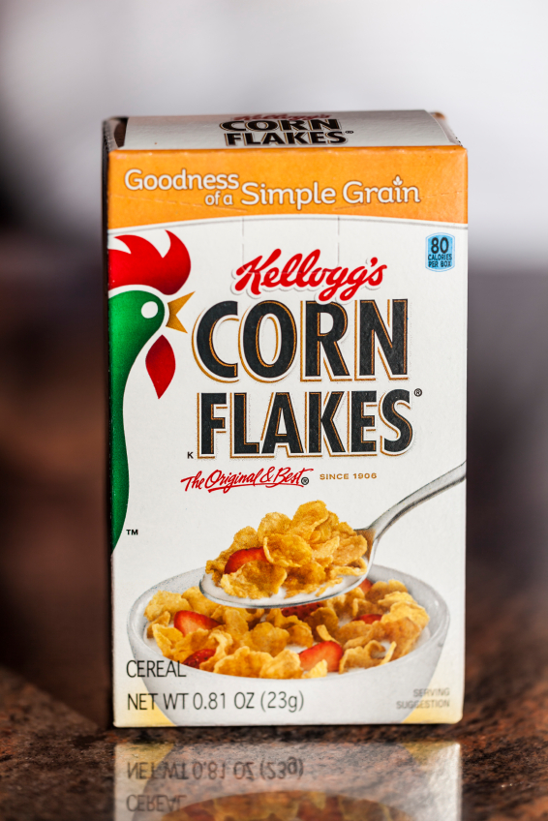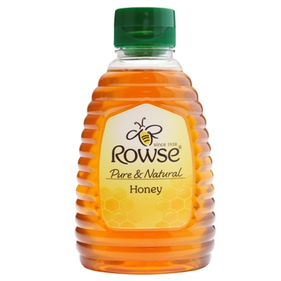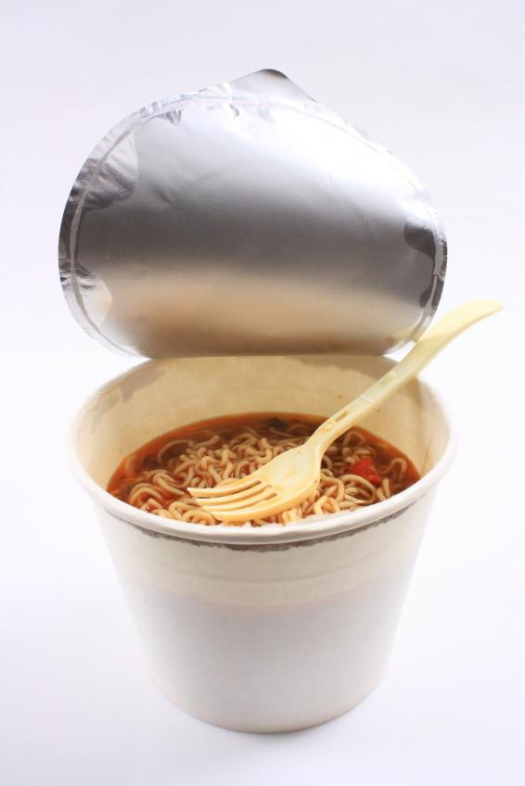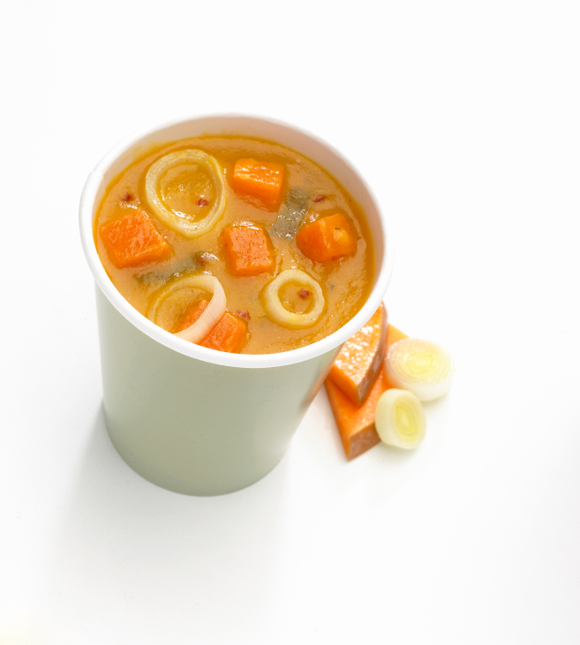

c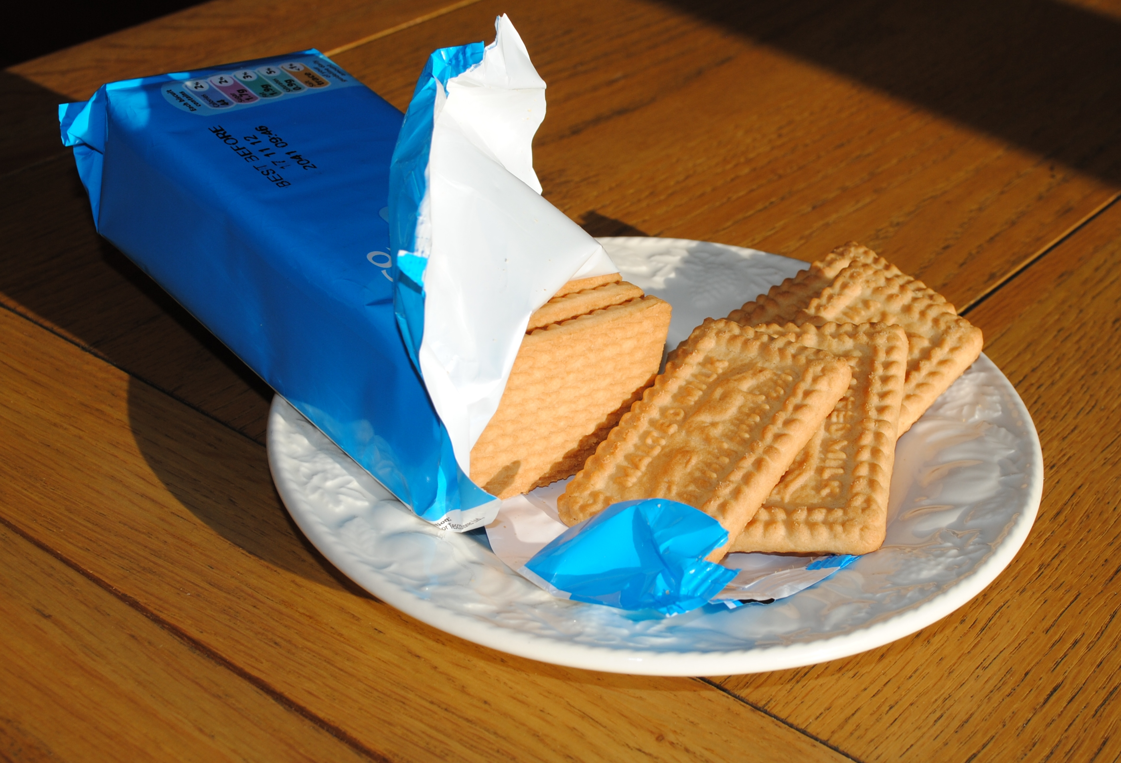 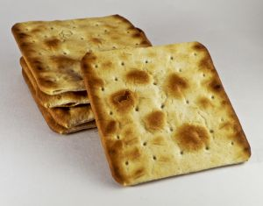 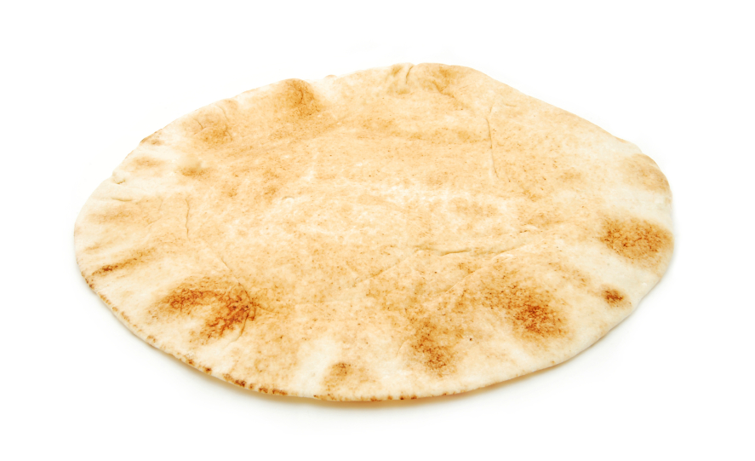

1.3 Reading abbreviations

Information
When you order from the canteen sheet, there are some abbreviations (these are short forms of words or phrases) you need to know.
For example USA is an abbreviation for the United States of America.
Abbreviations are sometimes the first letter or letters of each word, for example, IC = Item Code.
Or they use letters from the start and end of a word, for example, Qty = quantity.

Circle the abbreviations in the three different sections of a canteen sheet.
Check your answers.

Groceries
Price | Item | IC | Qty
£2.55 | Klg Cornflakes 500g | 964237
£1.99 | Econ Sqzy Honey | 389541
£0.60 | Economy ketchup 470g | 059236
£0.75 | Cup A Pasta Chicken Sgl | 158346
£1.75 | Cup A Soup Golden Veg pk | 125891

Biscuits & Bakery
Price | Item | IC | Qty
£0.55 | Economy Digestive 200g | 320784
£0.79 | Economy Rich Tea 300g | 439751
£1.85 | Milk Choc Hobnobs 300g | 498126
£0.49 | Economy Cream Crackers | 753921
£0.79 | Plain Pitta Bread 6’s | 694381

Turn over the page for the last section …
Toileteries & Health
Price | Item | IC | Qty
£2.05 | Colgate T/Paste 100ml | 320784
£2.40 | African Pride Shamp 400 ml | 439751

1.4 Choose an abbreviation from the box and match it with the meaning.
Check your answers
Klg t/paste econ sqzy shamp sgl veg pk choc

Glossary
Abbreviation | What it is short for | What it means
Klg | Kellogg’s | Kellogg’s is a brand/company name
 | economy | cheaper than normal price
 | toothpaste | you put this on a toothbrush to clean your teeth
 | squeezy | a plastic bottle you squeeze with your fingers to make the food come out
 | single | one
 | shampoo | you use this to wash your hair
 | vegetable | a plant that you can eat
 | pack | a small paper or cardboard container
 | chocolate | a sweet food made from cacao beans
What are the abbreviations that come after the numbers (100g, 300 ml)?
Abbreviation | What it is short for | What it means
g
ml

1.5 Ordering items (things) on the canteen sheet

Information
You can buy lots of different things from the canteen sheet, for example, a phone card, batteries, sweets, drinks, cards, fruit, biscuits and other items. If you don’t understand a word, you can look it up in your dictionary, ask your landing officer or ask your ESOL teacher.

Toiletries & Health

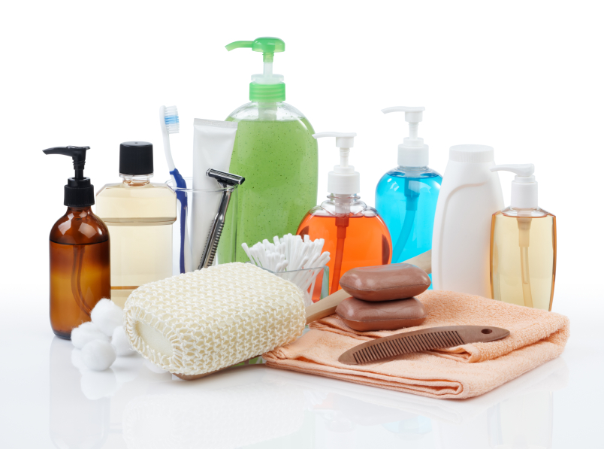

The items on the canteen sheet are in different sections. These are different parts that have a big word at the top that describes what you can buy.

Look at your own canteen sheet to help you with this. Can you put the letters into the right order to make the words? Now match them with the words.
Example: orgcreies = groceries 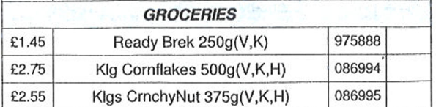

etewss | biscuits
dksrin | sweets
turif | tobacco
cocabot | drinks
ucbsitis | fruit

Check your answers.
1.6 Wordsearch

a. Can you find some of these words from the canteen sheet? Look up any new words in your dictionary. Draw a circle around the words. Read from top to bottom or left to right. Then check your answers.

biscuits | shampoo | juice | chocolate
toothpaste | cornflakes | coffee | soap
ketchup | deodorant | battery | crisps

y | t | m | o | b | i | s | c | u | i | t | s | n | m | c
x | s | h | h | a | r | o | o | j | h | o | s | y | p | h
d | h | t | r | t | u | o | w | p | c | k | h | e | m | o
e | a | c | x | t | p | z | d | a | o | p | o | v | t | c
o | m | f | o | e | j | m | l | l | r | t | k | k | e | o
d | p | b | s | r | z | m | z | l | n | c | w | i | m | l
o | o | a | u | y | e | i | c | o | f | h | e | c | p | a
r | o | t | p | m | z | y | t | g | l | e | p | c | a | t
a | f | r | p | u | s | e | r | y | a | n | w | r | f | e
n | w | c | o | f | f | e | e | m | k | o | g | i | w | r
t | o | o | t | h | p | a | s | t | e | l | a | s | q | f
a | e | m | t | z | c | o | m | m | s | o | a | p | o | m
q | w | e | r | j | u | i | c | e | p | f | a | s | i | l
i | p | v | s | t | k | m | p | q | r | e | r | b | j | o
c | u | k | e | t | c | h | u | p | l | f | a | c | c | o

1.7 Put the items (things) in the correct canteen section.

toiletries | groceries | sweets & snacks | batteries | drinks | biscuits & bakery
shampoo

Check your answers.

Unit 2 – Canteen sheet: ordering items (part 1)
2.1 Improve your grammar: making questions with ‘is’ or ‘are’
Look at these two questions:
How much are the cream crackers?
How much is the ketchup?

Information
The verb ‘to be’:
We use ‘is’ with singular nouns (one item) and ‘are’ with plural nouns (two or more).
‘cream crackers’ is plural – There are lots of cream crackers in a packet.
‘ketchup’ is singular – There is one bottle of ketchup.
In questions, the verb (is or are) goes before the noun – Is the ketchup on the table? Are the cream crackers broken?

Complete these questions with ‘is’ or ‘are’ and then answer the questions by finding the price on the canteen sheet on page 6:
- How much are the digestive biscuits? £ 0.55
- How much …… the Cup A Pasta? £
- How much …... the honey? £
- How much …... the cream crackers £
- How much …... the Cup A Soup? £
- How much …... the cornflakes £
- How much …... the Hobnobs? £
- How much …... the toothpaste? £
What is the total amount? £
Now check your answers ..
2.2 Containers and packaging
Draw a line to match each container word with the picture. Then match the container with the item. Use your dictionary to help you.
Check your answers.
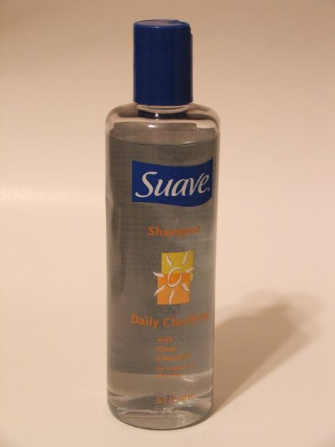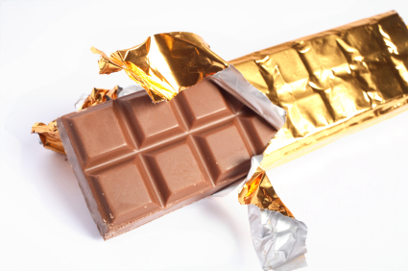
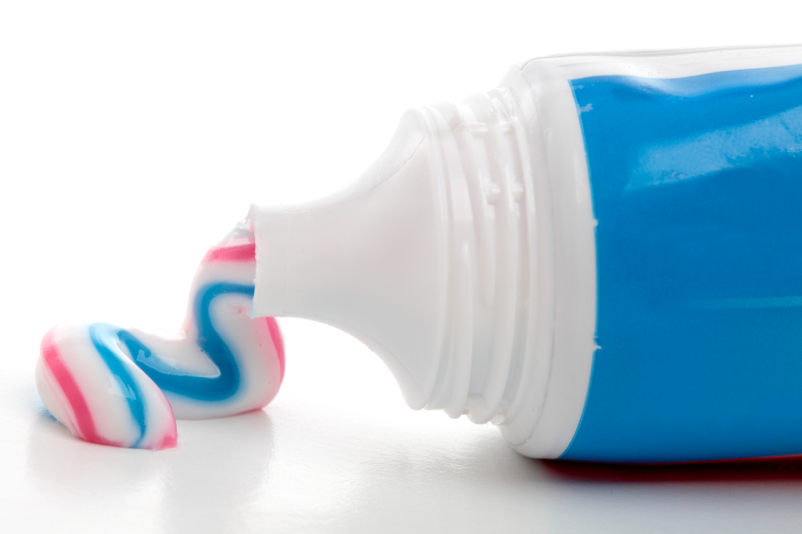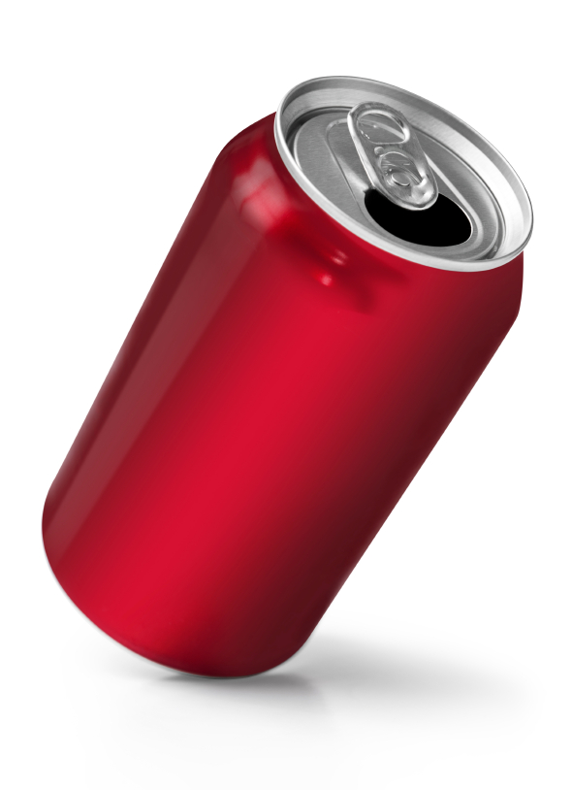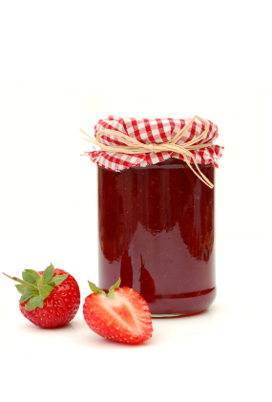

a bottle of a jar of a packet of a bar of a can of a tube of
jam biscuits chocolate lemonade shampoo toothpaste
Now complete the sentences and check your answers.
Ahmed wants to buy a ……….…………. of orange squash and a …………… of chocolate.
Maria wants to buy a …………..…….. of coffee, a ………...………. of toothpaste and a ………….. of lemonade.
What do you want to buy? Write one or two sentences here and ask someone (a friend, a teacher) to check it.
........................................................................................................................

........................................................................................................................

……………………………………………………………………………………….

2.3 Read about Nick and what he orders from the canteen sheet. Then answer the questions.
Glossary
a portion (n.) = amount of food for one person
a must (n.) = something you really need or want
a selection (n.) = a group of things to choose from
a snack (n.) = a small amount of food you eat between meals
to put on weight = get fatter



‘My name’s Nick. The food here is quite good most of the time but the portions are really small. I often get hungry. We get the breakfast pack the day before and sometimes I eat it that evening – I just can’t wait until morning! So buying extra food is a must and I order snacks or biscuits from the canteen sheet every week. There’s a good selection and I always buy a couple of packets of economy digestives or chocolate chip cookies. They’re not too expensive and they fill you up! I like chocolate and crisps so I usually order some of those too. I occasionally buy a snack like a Cup A Pasta Chicken or Cup A Soup but I never order cakes as I don’t want to put on weight. I often buy things like shower gel, toothpaste and deodorant – I like to keep clean and I like to smell nice too!

- Does Nick like the food in prison?
- Why does he get hungry?
- Why does he eat his breakfast pack the day before?
- What food does he order from the canteen sheet?
- Why does he never buy cakes?
- What toiletries does he buy?
Check your answers.

2.4 Improve your grammar: adverbs of frequency

a) Nick talks about how often he does something. Look at these words. They are called adverbs of frequency. Find the words in the story about Nick above and underline them.

usually sometimes never always often

Put the words in the correct place on the line.

0% 100%
never |  |  |  | always

Check your answers.

b) Practise your grammar: look at these sentences -
I never order cakes.
I always buy shower gel.

Information
Verbs are doing words, for example, to eat, to buy, to wash. Adverbs usually go in front of the verb.

Write the sentences and put the adverb in the right place.
- Maria orders cakes (usually) ……………………………………………………………..…
- Ahmed buys biscuits (never) ……………………………………………………………..…
- Abdullah watches TV (sometimes) …………………………………………………………...
- My friend drinks coffee (always) …………………………………………………………….
- Lin goes to the library (often) …………………………………………………………………
Now check your answers.

c) Think about yourself. How often do you do something? Write some sentences using usually, sometimes, never, always, often. Ask someone (a friend, a teacher) to check them.

Example: I never order peanuts because don’t like them.

.........................................................................................................................................

.........................................................................................................................................

.........................................................................................................................................

.........................................................................................................................................

.........................................................................................................................................

.........................................................................................................................................

.........................................................................................................................................

.........................................................................................................................................

.........................................................................................................................................

.........................................................................................................................................

Unit 3 – Canteen sheet: ordering items (part 2)

3.1 Improve your grammar: ‘going to …’ (future)
Look at these sentences -
I’m going to watch TV this evening.

He’s going to order some biscuits next week.

We’re going to the gym this afternoon.

We use am/is/are going to … to talk about future plans. When we talk about our plans, we normally use the short form:
I am going to – I’m going to He is going to – He’s going to
We are going to – We’re going to

Every week, Nick looks at the canteen sheet and decides what he wants to order. Next week, he decides he wants

- a packet of crisps b) a bar of chocolate
c) Cup A Soup vegetable d) some shower gel
- a tube of toothpaste
Write some sentences about what Nick is going to order next week.

Example: a) Nick is going to buy a packet of crisps.

b)
c)
d)
e)
Check your answers.

3.2 Practise your grammar: ‘not going to …’ (future)
He’s not going to order shampoo next week.
I’m not going to watch TV this evening.
We’re not going to the gym tomorrow.

What are you going to buy or not going to buy next week?
Write three or four sentences here and ask someone (a friend, a teacher) to check them.

.........................................................................................................................................

.........................................................................................................................................

.........................................................................................................................................

.........................................................................................................................................

.........................................................................................................................................

.........................................................................................................................................

.........................................................................................................................................

.........................................................................................................................................

.........................................................................................................................................

.........................................................................................................................................

3.3 More practice: ‘… going to’ (future)

Complete the sentences. Use … going to + one of these verbs:

eat go write make have watch

Example: I feel dirty. I’m going to have a shower.
- Nick’s hungry. He …………………………………………….. some biscuits.
- I need to get soap. I ………………………………………….……to the canteen.
- Eastenders is on at 7 pm. I ………………………………………….. TV this evening.
- Nick got a letter from his wife. He …………………………..…… back to her this afternoon.
- I’m thirsty. I …………………………………..…. a cup of tea.
Check your answers.
.
3.4 Asking for help when things go wrong

Every week, Nick orders food and other items from the canteen sheet but sometimes things go wrong. Last week, he ordered a packet of economy digestive biscuits but he received a packet of fruit shortcake biscuits instead. What did he say to the landing officer?

Put the words in the correct order to make a correct sentence/question. Practise saying them.
you help please can me ?

a.

order mistake with there’s a been my

b.
didn’t I order this

c.
should what do I ?

d.

Problems: match the two parts of the sentences below.

I ordered chocolate biscuits but | it was shower gel.
It looked like shampoo but | I got digestives instead.
I wanted a can of Coca Cola but | I got a can of Fanta Orange instead.

Now check your answers.

Unit 4 – Reading a prison menu

4.1 Reading a menu form – improve your vocabulary

a) Look at Wednesday’s menu below. Is it similar to the menu where you are? What would you choose for lunch and dinner?
Lunch
Choice A Tuna and Onion Sandwich   [ ]
Choice B Vegetable Stew 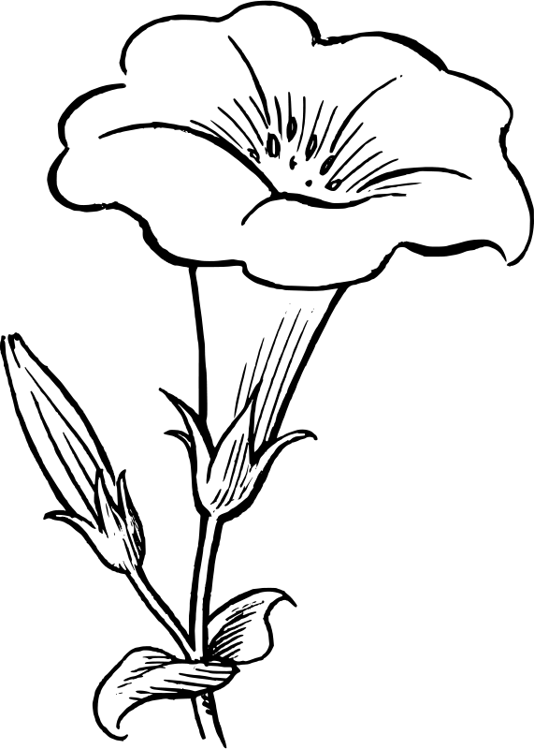 V [ ] Choice C Egg Mayo Sandwich  V [ ]
Choice D Pork Cutlet in Breadcrumbs 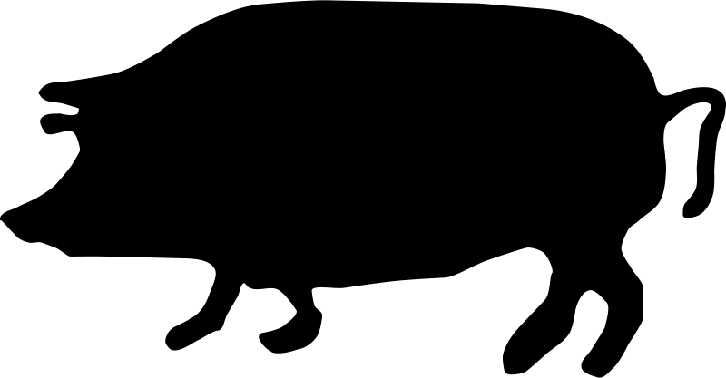 [ ]
Choice E Halal Turkey Burger in a Bun 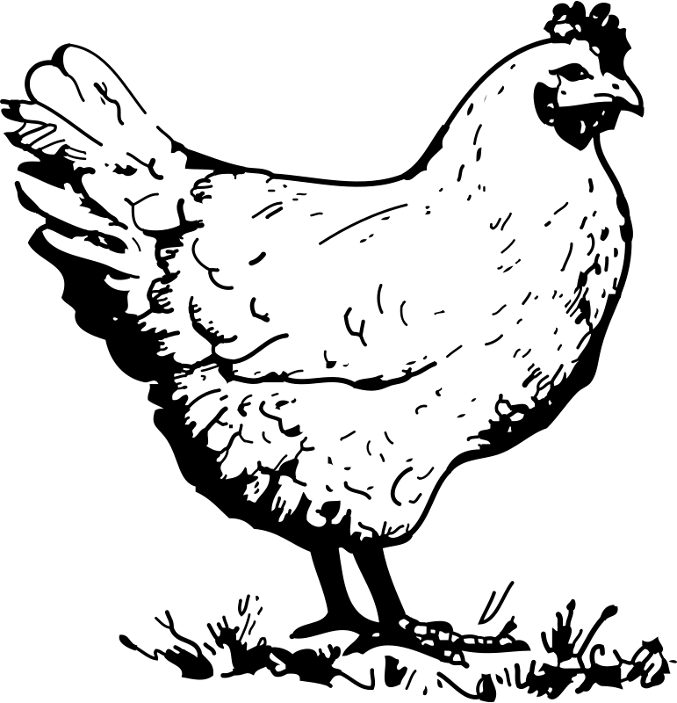 [ ]
+ Packet of Crisps [ ] + Fresh Fruit  [ ]

Dinner
Choice A Beef Lasagne with salad 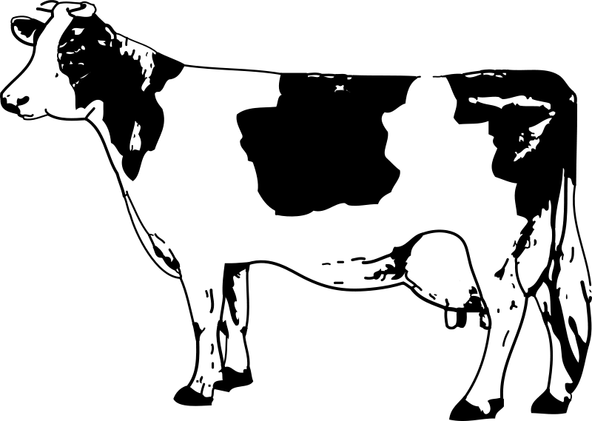 [ ]
Choice B Vegan Cottage Pie  [ ]
Choice C Roast Beef and Yorkshire Pudding  [ ]
Choice D Salmon Fishcakes and Salad  [ ]
Choice E Halal Sweet and Sour Chicken  [ ]
Sweet
Choice F Apple crumble and custard  [ ]
Choice H Fresh Fruit   [ ]

b) Do you know the words in bold in the menu? If not, look them up in your dictionary or the glossary below.
Glossary
vegetable stew = vegetables cooked in a sauce
mayo = mayonnaise (a sauce made from egg, oil, vinegar)
pork cutlet = a small flat piece of pork on the bone
vegan cottage pie = vegetables in a sauce covered with mashed potato
yorkshire pudding = baked food made from flour, milk and eggs, eaten with roast meat
apple crumble = a sweet dish of apples covered with a mixture of flour, butter and sugar and cooked in the oven
custard = a sweet yellow sauce made with milk, eggs, sugar and flour. we usually eat it hot with puddings e.g. apple crumble.

c) Different diets: the menu uses symbols to show the different diets. Match the symbol to the diet/food type. Check your answers.

Symbol | Diet/food
 | fish  chicken or turkey  beef  healthy  Halal  vegan  vegetarian  pork




V









d) Check your understanding. Circle the correct word. Check your answers.

- A vegetarian / vegan is someone who does not eat meat or fish.

- Halal / beef is meat that comes from an animal killed according to Islamic law.

- A vegetarian / vegan is someone who does not eat any meat, fish or dairy products.

- A healthy / vegan diet keeps you fit.

- Beef / Pork is meat that comes from a pig.

- Pork / Beef is meat that comes from a cow.
4.2. Read what Gabriela says about the food in her prison and then look at the questions. Are they true (T) or false (F)?


‘The food here isn’t too bad.
I often have a sandwich for lunch, usually hummus or cheese and onion, something like that. I never eat meat so there’s not so much choice.
I always have some fruit or a packet of crisps … it depends how I’m feeling when I fill in the form. I sometimes order something different, maybe fish and salad, but I’m not keen on salad really.
For dinner, I usually have vegetable pie or a couple of boiled eggs with bread and butter. The vegan cottage pie is actually quite tasty …. and I really like apple crumble and custard but we don’t get that very often.
I love cream cakes but they’re never on the menu!

- Gabriela thinks the food in the prison is horrible. T / F
- She’s vegetarian. T / F
- She doesn’t like salad. T / F
- She likes the vegan cottage pie. T / F
- She has apple crumble every day. T / F
- Find the words or phrases in the text which mean:
- quite good (2 words)...............................
- doesn’t really like (4 words)....................
- tastes very good (1 word)......................
4.3 Sentences
Put in the commas (,) and full stops (.) and capital letters (L) to make three sentences.
the food here isn’t too bad I often have a sandwich for lunch i usually choose tuna and sweetcorn or cheese and onion I never eat meat so there’s not much choice for me
Check your answers.

4.4 Spelling
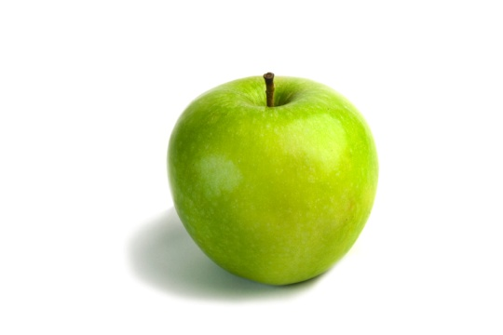
Can you spell these words from the text? Put in the missing letters.

- a p p l e
- s _ n d _ i c _
- c _ e e _ _
- _ r u _ t
- c r _ _ p _
- v _ g _ _ a b _ e
- b _ i l _ d
- b _ e _ _
Now check your answers.

What do you think about the food in your prison? What do you usually eat?
Write three or four sentences here and ask someone (a teacher, a librarian) to check them.

You can begin like Gabriela -

The food here is ....
.........................................................................................................................................

.........................................................................................................................................

.........................................................................................................................................

.........................................................................................................................................

.........................................................................................................................................

.........................................................................................................................................

.........................................................................................................................................

.........................................................................................................................................

.........................................................................................................................................

.........................................................................................................................................

.........................................................................................................................................

.........................................................................................................................................

.........................................................................................................................................

Unit 5 – What food is good or bad for me?
5.1 How many food words do you know? Look at the words and match them with the food in the picture:
apple | sweetcorn | green pepper | grapes | tomatoes | sausages
Meat | lettuce | cabbage | yellow pepper | salami | chilli pepper
apple

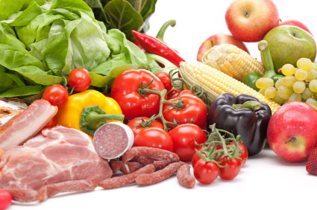

5.2 Put each food item into the correct column. Add more examples.
Fruit | Vegetables | Meat
apple

Check your answers on. Did you spell the words correctly? If not, write them in your personal dictionary and practise writing them.

5.3 Vocabulary: healthy and unhealthy food

Look at the picture below. It shows you the how much of each food group you should eat. Did you know that it is good for you to eat fruit, vegetables, bread, rice, potatoes and pasta? They are healthy foods.

Food and drinks which are high in fat and / or sugar, such as chocolate, cola and burgers are not good for you. You can eat some meat, fish, eggs and beans, or milk and dairy foods when you want, but not too much.

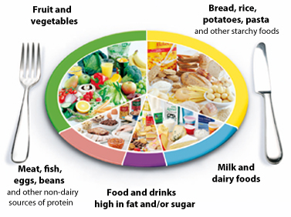

Did you understand the text? Answer the questions. Are they true (T) or false (F)?

1. Unhealthy means it is bad for you. T / F
2. Pasta is unhealthy. T / F
3. Food that is ‘high in’ sugar has lots of sugar in it. T / F
4. It is healthy to eat vegetables every day. T / F
5. Chocolate has very little sugar in it. T / F

Check your answers.

5.4 Vocabulary: ‘fast foods’

Do you like ‘fast foods’? These can be high in fat, which is unhealthy. Put the letters in the right order to make the words. Next match them to the pictures.

- zizpa pizza | 1. 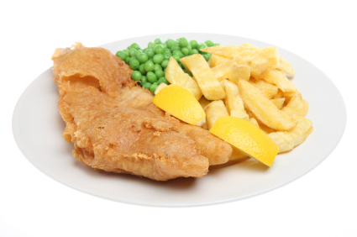
- sihf & pschi | 2.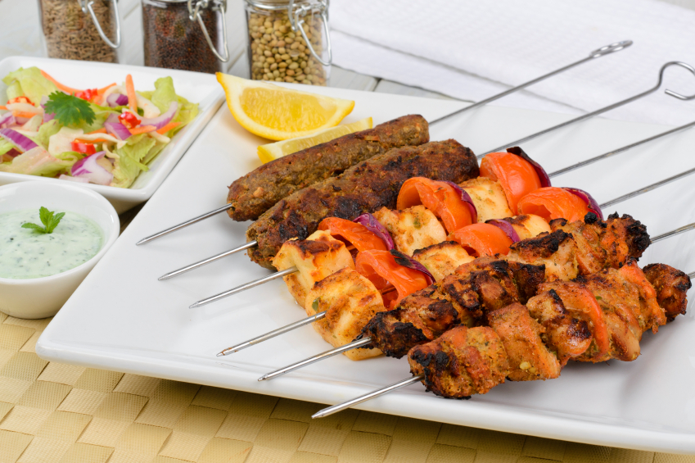
- urbreg | 3.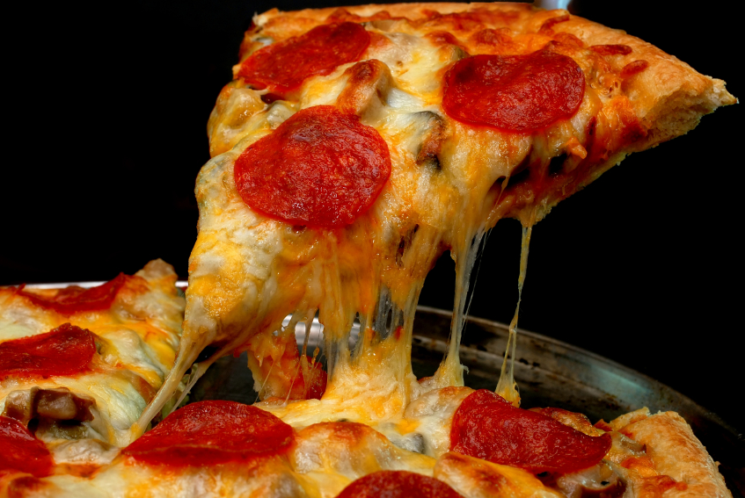
- sotra nickech | 4.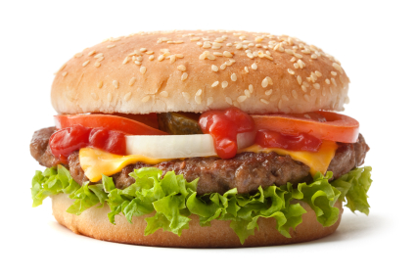  s
- kaebsb | 5. 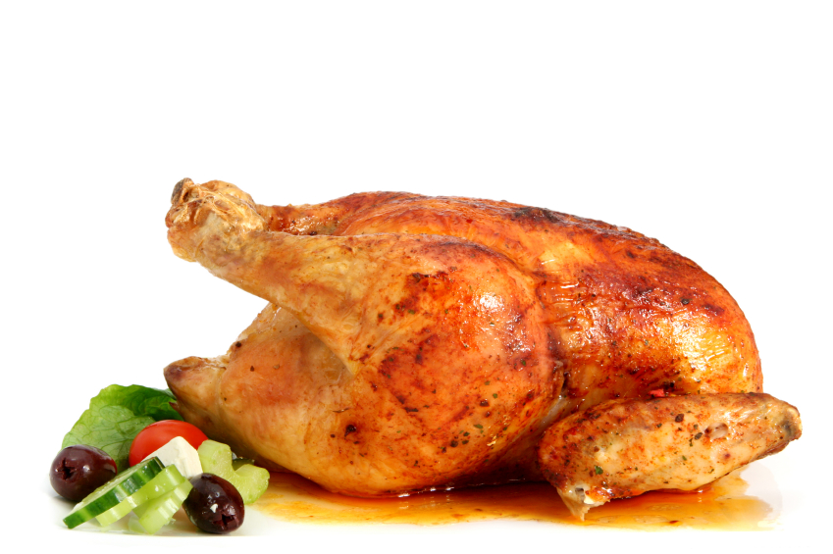
Check your answers.

Test yourself! How much can you remember from this workbook?

1. Match the abbreviations from the canteen sheet with the longer words.

Shamp | quantity
Ml | shampoo
Sgl | gram
G | millilitre
Qty | single

2. Are these sentences true T or false F? Where can you find things on the canteen sheet? What sections do you need?

I can find breakfast cereals in GROCERIES. T / F

I can find shampoo in BISCUITS AND BAKERY. T / F

I can find ketchup in TOILETRIES. T / F

Check your answers.

3. Choose the correct phrase for the picture.
a bar of coffee  a bar of chocolate  a tube of tea | 
a jar of jam  a jar of cola  a bottle of jam | 
a packet of toothpaste  a tube of toothpaste  a bar of toothpaste | 
a can of jam  a jar of Coca-cola  a can of Coca-cola | 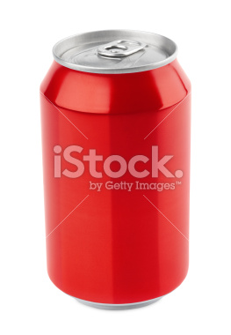
a packet of shampoo  a jar of jam  a bottle of shampoo | 
a packet of biscuits  a bar of biscuits  a packet of chocolate | 

Check your answers

4. The words are not in the right place. Can you put them in the correct order to make sentences? Then check your answers.

- sweets I order never

- sometimes honey my bread buy I for

- because I smoking always I love tobacco buy

5. Can you find the mistakes in these sentences? Write them correctly.

e.g. You going to the mosque. You are going to the mosque.

- I is going to buy cornflakes.

- He going to the gym.

- We going to eat on the wing today.

- You going to the canteen.

Check your answers.

Things I can do

I can do this!

? I need more practice

I can …. | ?
read and understand a canteen sheet
understand some abbreviations used on a canteen sheet
find the prices of things on a canteen sheet
understand new words on a canteen sheet
use ‘is’ and ‘are’ in questions
say how often you order different items
use sometimes/usually/always/never in a sentence
use ‘going to’ to talk about future orders
ask for help when things go wrong
say what food is good or bad for you
understand some new food words
read and understand a menu form
understand the symbols used on a menu form

Answers

Unit 1 – Canteen sheet: important words you need to know

1.1 A canteen sheet is a list of things you can buy

1.2 Reading a canteen sheet – vocabulary
cornflakes digestive biscuit honey cup a soup
cream crackers cup a pasta pitta bread





1.3 Reading abbreviations
GROCERIES
Price | Item | IC | Qty
£2.55 | Klg Cornflakes 500g (Kelloggs) | 964237
£1.99 | Econ Sqzy Honey (Economy Squeezy) | 389541
£0.60 | Economy ketchup 470g | 059236
£0.75 | Cup A Pasta Chicken Sgl (Single) | 158346
£1.75 | Cup A Soup Golden Veg pk (Vegetable pack) | 125891

BISCUITS & BAKERY
Price | Item | IC | Qty
£0.55 | Economy Digestive 200g | 320784
£0.79 | Economy Rich Tea 300g | 439751
£1.85 | Milk Choc Hobnobs 300g (Chocolate) | 498126
£0.49 | Economy Cream Crackers | 753921
£0.79 | Plain Pitta Bread 6’s | 694381

TOILETRIES & HEALTH
Price | Item | IC | Qty
£2.05 | Colgate T/Paste 100ml (Toothpaste) | 320784
£2.40 | African Pride Shamp 400 ml (Shampoo) | 439751

1.4
Abbreviation | What it is short for | What it means
Klg | Kellogg’s | Kellogg’s is a brand/company name
econ | economy | cheaper than normal price
t/paste | toothpaste | you put this on a toothbrush to clean your teeth
sqzy | squeezy | a plastic bottle you squeeze with your fingers to make the food come out
sgl | single | one
shamp | shampoo | you use this to wash your hair
veg | vegetable | a plant that you can eat
pk | pack | a small paper or cardboard container
choc | chocolate | a sweet food made from cacao beans
g | gram | There are 1000 grams in a kilogram (kg).
ml | millilitre | There are 1000 millilitres in a litre.

1.5
etewss | biscuits
dksrin | sweets
turif | tobacco
cocabot | drinks
ucbsitis | fruit

1.6 Wordsearch
 |  |  |  | b | i | s | c | u | i | t | s |  |  | c
 | s |  |  | a |  |  |  |  |  |  |  |  |  | h
d | h |  |  | t |  |  |  |  | c |  |  |  |  | o
e | a |  |  | t |  |  |  |  | o |  |  |  |  | c
o | m |  |  | e |  |  |  |  | r |  |  |  |  | o
d | p |  |  | r |  |  |  |  | n |  |  |  |  | l
o | o |  |  | y |  |  |  |  | f |  |  |  |  | a
r | o |  |  |  |  |  |  |  | l |  |  | c |  | t
a |  |  |  |  |  |  |  |  | a |  |  | r |  | e
n |  | c | o | f | f | e | e |  | k |  |  | i
t | o | o | t | h | p | a | s | t | e |  |  | s
 |  |  |  |  |  |  |  |  | s | o | a | p
 |  |  |  | j | u | i | c | e |  |  |  | s
 |  | k | e | t | c | h | u | p

1.7

Toiletries | Groceries | Sweets & Snacks | Batteries | Drinks | Biscuits & Bakery
shampoo  toothpaste  soap  deodorant | cornflakes  ketchup | chocolate  crisps | battery | juice  coffee | biscuits

Unit 2 – Canteen sheet: ordering items (part 1)

2.1 Improve your grammar: making questions with ‘is’ or ‘are’

- How much are the digestive biscuits? £ 0.55
- How much is the Cup A Pasta? £ 0.75
- How much is the honey? £ 1.99
- How much are the cream crackers £ 0.49
- How much is the Cup A Soup? £ 1.75
- How much are the cornflakes £ 2.55
- How much are the Hobnobs? £ 1.85
- How much is the toothpaste? £ 2.05
What is the total amount? £11.98

2.2 Containers and packaging
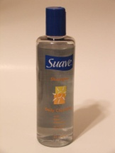
a bottle of shampoo a packet of biscuits a bar of chocolate


a can of lemonade a jar of jam a tube of toothpaste

Ahmed wants to buy a bottle of orange squash and a bar of chocolate
Maria wants to buy a jar of coffee, a tube of toothpaste and a can of lemonade.

2.3 What Nick says and what he orders from the canteen sheet..

Does Nick like the food in prison? Yes, it’s quite good.
Why does he get hungry? Because the portions are very small.
Why does he eat his breakfast pack the day before? Because he gets hungry.
What food does he order from the canteen sheet? Biscuits, cookies, chocolate, crisps, Cup a Pasta Chicken, Cup a Soup.
Why does he never buy cakes? Because he doesn’t want to put on weight.
What toiletries does he buy? Shower gel, toothpaste and deodorant.

2.4 Improve your grammar: adverbs of frequency

0% 100%
never | sometimes | often | usually | always

2.5
- Maria usually orders cakes
- Ahmed never buys biscuits
- Abdullah sometimes watches TV
- My friend always drinks coffee
- Lin often goes to the library

Unit 3 – Canteen sheet: ordering items (part 2)

3.1 Improve your grammar: ‘going to …’ (future)

a) Nick is going to buy a packet of crisps.
b) Nick is going to buy a bar of chocolate.
c) Nick is going to buy a Cup A Soup vegetable.
d) Nick is going to buy some shower gel.
e) Nick is going to buy a tube of toothpaste.

3.3 Further practice: ‘… going to’ (future)

a) Nick’s hungry. He’s going to eat some biscuits.
b) I need to get soap. I’m going to go to the canteen.
c) Eastenders is on at 7 pm. I’m going to watch TV this evening.
d) Nick got a letter from his wife. He’s going to write back to her this afternoon.
e) I’m thirsty. I going to make a cup of tea.

3.4 Asking for help when things go wrong
a. Can you help me please?
b. There’s been a mistake with my order.
c. I didn’t order this.
d. What should I do?

I ordered chocolate biscuits but | I got digestives instead
It looked like shampoo but | it was shower gel.
I wanted a can of Coca Cola but | I got a can of Fanta Orange instead.

Unit 4 – Reading a prison menu

Symbol | Diet/food
 | Halal  fish  vegan  vegetarian  pork  chicken or turkey  healthy  beef



V



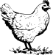


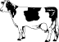

d)
- A vegetarian is someone who does not eat meat or fish.

- Halal is meat that comes from an animal killed according to Islamic law.

- A vegan is someone who does not eat any meat, fish or dairy products.

- A healthy diet keeps you fit.

- Pork is meat that comes from a pig.

- Beef is meat that comes from a cow.
4.2
- Gabriela thinks that the food in the prison is horrible. F
- She’s vegetarian. T
- She doesn’t like salad. T
- She likes the vegan cottage pie. T
- She has apple crumble every day. F
- Find the words/expressions in the text which mean:
- quite good = not bad
- doesn’t really like = not very keen on
- tastes very good = tasty
4.3 Add the punctuation
The food here isn’t too bad. I often have a sandwich for lunch. I usually choose hummus or cheese and onion. I never eat meat, so there’s not much choice for me.
4.4 Spelling
- apple
- sandwich
- cheese
- fruit
- crisps
- vegetable
- boiled
- bread

Unit 5 – What food is good or bad for me?
5.1
apple | sweetcorn | green pepper | grapes | tomatoes | sausages
meat | lettuce | cabbage | yellow pepper | salami | chilli pepper
apple

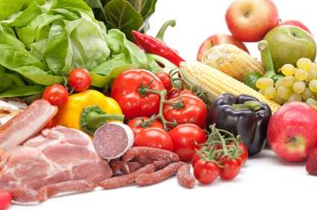

5.2 Answers and more examples
fruit | vegetables | meat
apple  grapes  (bananas, berries, oranges, pears, plums) | cabbage  lettuce  peppers  sweetcorn  tomatoes  (beans, carrots, lentils, onions, peas, potatoes) | pork  beef  salami  sausages  (chicken, kebabs, lamb, mutton)

Unit 5.3
1. Unhealthy means it is bad for you. T
2. Pasta is unhealthy. F
3. Food that is ‘high in’ sugar has lots of sugar in it. T
4. It is healthy to eat vegetables every day. T
5. A bar of chocolate has very little sugar in it F

5.4. Vocabulary: ‘fast food’

a) pizza 3
b) fish & chips 1
c) burger 4
d) roast chicken 5
e) kebabs 2

Test yourself! Answers
1. Match the abbreviations from the canteen sheet with the longer words.
shamp | shampoo
ml | millilitre
sgl | single
g | gram
Qty | quantity

2. Are these sentences true T or false F?
I can find breakfast cereals in GROCERIES. T
I can find shampoo in BISCUITS AND BAKERY. F (you need to look in TOILETRIES)
I can find ketchup in TOILETRIES. F (you need to look in GROCERIES)

3. Choose the correct phrase for the picture
a bar of chocolate | 
a jar of jam | 
a tube of toothpaste | 
a can of Coca-cola | 
a bottle of shampoo | 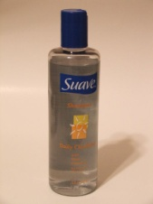
a packet of biscuits | 
4.
- I never order sweets.
- I sometimes buy honey for my bread/ Sometimes I buy honey for my bread.
- I always buy tobacco because I love smoking.
5. Write the sentences correctly.
- I am going to buy cornflakes. I’m going to buy cornflakes.
- He is going to the gym. He’s going to the gym.
- We are going to eat on the wing today. We’re going to eat on the wing today
- You are going to the canteen. You’re going to the canteen.

